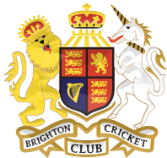

BRIGHTON CRICKET CLUB
ANNUAL GENERAL MEETING
Wednesday 11 August 2021
Venue: TBC
7.00pm

NOTICE OF MEETING

All current financial members of the Brighton Cricket Club Incorporated are advised that the Annual General Meeting will take place on August 11, 2021 according to the attached agenda.

In accordance with the Rules of the club all General Committee and executive positions are spilled, and all positions are elected annually. All current General Committee members and Executive members are invited to nominate for re-election. Similarly, any other members are invited to nominate.

The attached nomination form must be duly completed and received by the Secretary no later than August 9, 2021 being three business days prior to the Annual General Meeting.

